Process Report Visualization Guide

Overview
This guide demonstrates how to visualize the process data generated by the CLI-tool.ps1 script using LibreOffice Calc and interactive HTML charts.

Option A: LibreOffice Calc
Initial Setup:
- Open LibreOffice Calc
- Import your CSV file (File → Open, select CSV file)
- In the Text Import dialog, ensure proper delimiter detection (comma)
- Verify column types are correctly detected
- Create visualizations using Insert → Chart
Step-by-Step Chart Creation:

Chart 1: Top 10 Processes by Memory Usage (Bar Chart)
- Sort data by memory usage:
  - Select all data (Ctrl+A)
  - Go to Data → Sort
  - Sort by "MemoryUsageMB" column, Descending
  - Click OK
- Select top 10 processes:
  - Select rows 2-11 (header + top 10 processes)
  - Include columns: ProcessName and MemoryUsageMB
- Create the chart:
  - With data selected, go to Insert → Chart
  - Choose "Column" chart type → "Normal" subtype
  - Click Next → Next → Next
  - Set title: "Top 10 Processes by Memory Usage"
  - Set X-axis title: "Process Name"
  - Set Y-axis title: "Memory Usage (MB)"
  - Click Finish
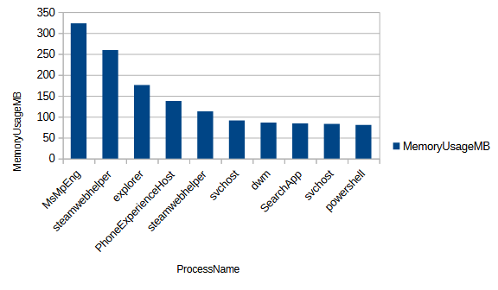Chart 1: Top 10 Processes by Memory Usage (Bar Chart)

Chart 2: Processes per User (Donut Chart)
- Create a pivot table:
  - Select all data (Ctrl+A)
  - Go to Data → Pivot Table → Insert or Edit
  - Click OK
  - Drag "User" to Row Fields
  - Drag "ProcessID" to Data Fields (it will count processes)
  - Click OK
- Create pie chart from pivot:
  - Select the pivot table results
  - Go to Insert → Chart
  - Choose "Pie" chart type → "Donut" subtype
  - Click Next → Next → Next
  - Set title: "Processes per user"
  - Enable "Show legend"
  - Click Finish
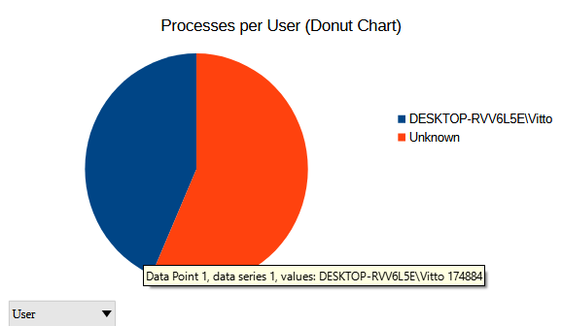Chart 2: Processes per User (Donut Chart)
Chart 3: CPU Usage Distribution vs Memory Usage Distribution
- Select data:
  - ProcessName, CPUUsage, and MemoryUsageMB columns
- Insert → Chart → Choose "XY (Scatter)" chart
- Click Next → Next → Next
- Set title: "CPU Usage Distribution vs Memory Usage Distribution"
- Configure axes:
  - X-axis: CPU Usage (seconds)
  - Y-axis: Memory Usage (MB)
- Click Finish
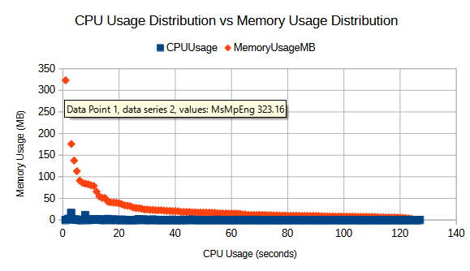

Option B (better looking, interactive): HTML Interactive Dashboard

Step 1: Get the Dashboard
Save the HTML dashboard artifact as dashboard.html in your project folder.

Step 2: Generate Data
Run your PowerShell script:
.\CLI-tool.ps1 -OutputFormat CSV -OutputFile "processes.csv"
Or for JSON:
.\CLI-tool.ps1 -OutputFormat JSON -OutputFile "processes.json"

Step 3: Open the Dashboard
Option A: Double-click dashboard.html to open in browser, then upload your file
Option B: Run a local server and serve the dashboard there

Step 4: Upload the script output
Either drag and drop your output file into the "Load Your Process Data" box or click "Browse" and choose your file in the explorer window

Using the sortable Process Details table
- Click column headers to sort by that column – ascending, descending, default
- Default sort: Memory usage (highest first)

Troubleshooting
- File not loading: Check file format is CSV or JSON with correct column headers
- Charts not showing: Check browser console (F12) for errors

Illustrations:
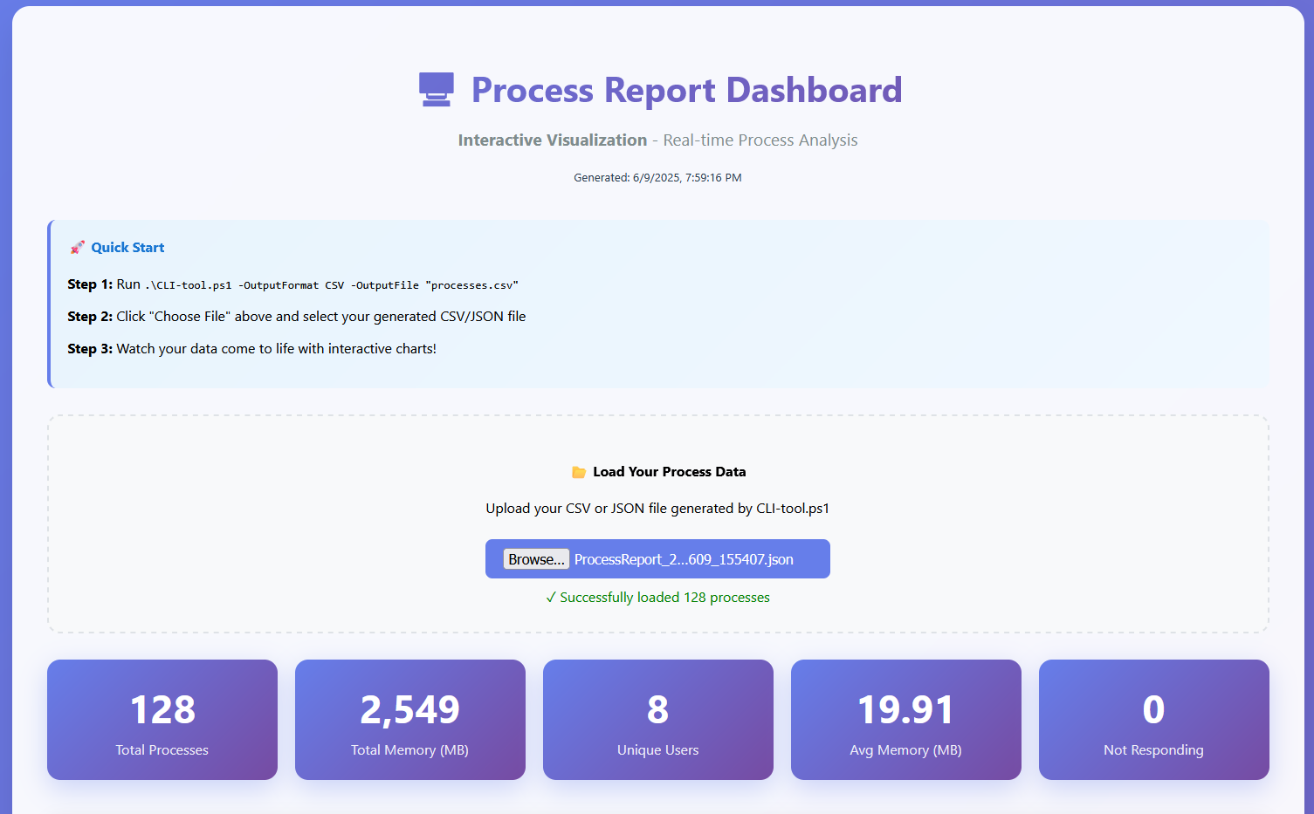Illustration 1: Dashboard Overview

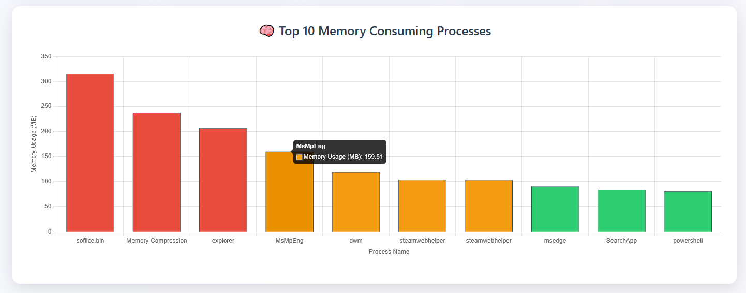Illustration 2: Top 10 Memory Consuming Processes Chart

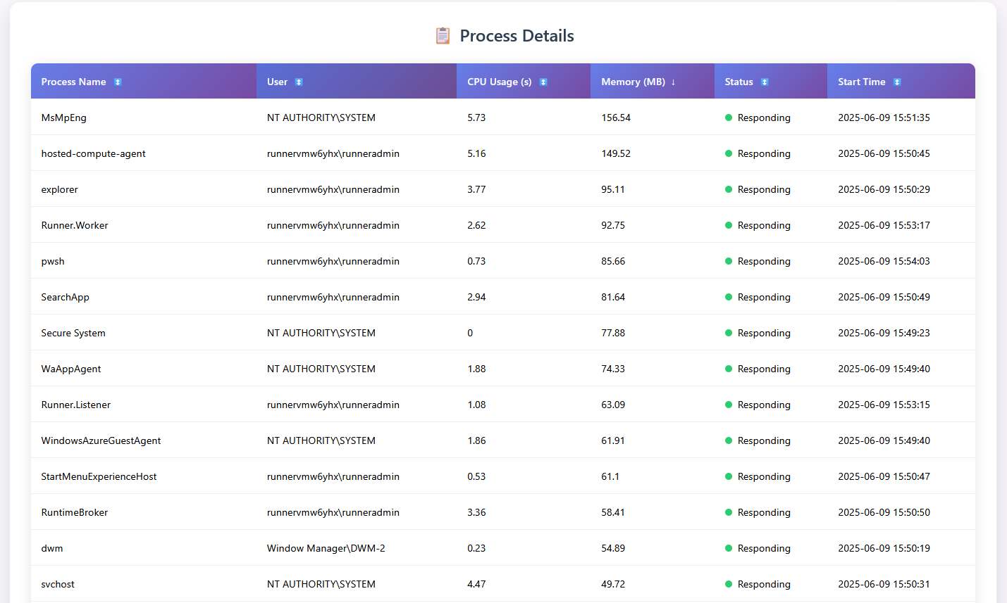Illustration 5: Sortable Process Details Chart
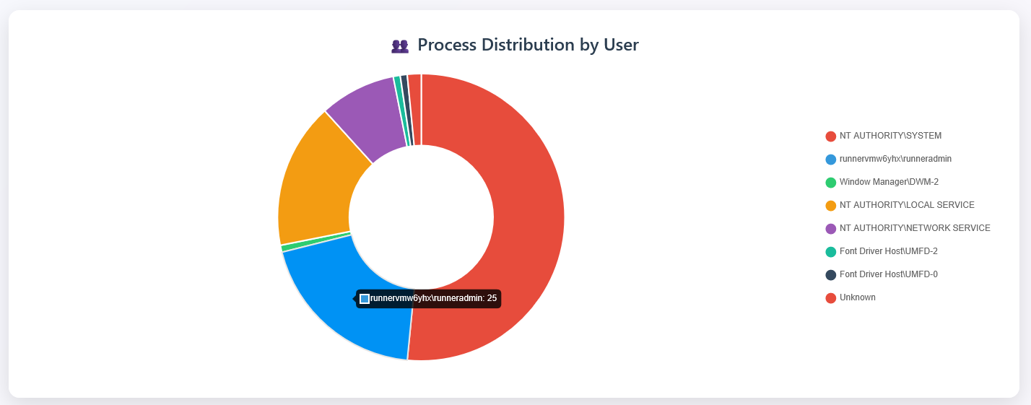Illustration 3: Process Distribution by User Chart
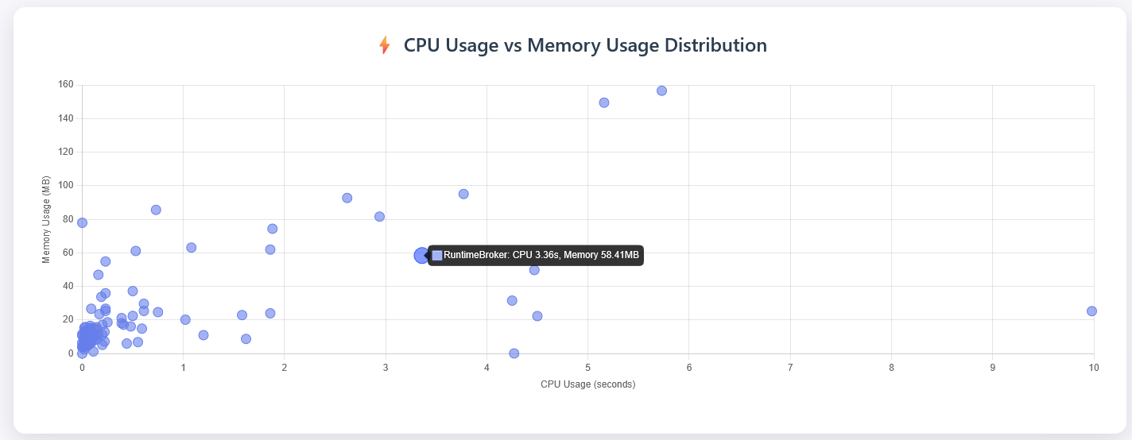Illustration 4: CPU Usage vs Memory Usage Distribution Chart

